  

Haringey Carbon Challenge Diary

|  |  |
| --- | --- |
| **Day** | **Carbon Reductions** |
| Monday |  |
| Tuesday |  |
| Wednesday |  |
| Thursday |  |
| Friday |  |
| Saturday |  |
| Sunday |  |

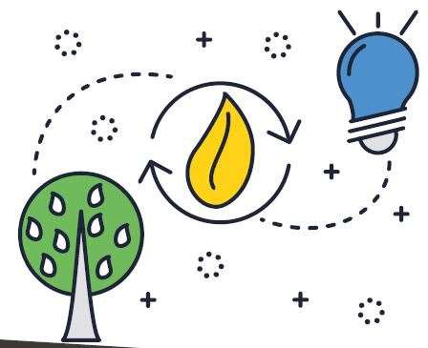Active travel Saving water Reducing waste Energy